FRUTI VENDING BAG

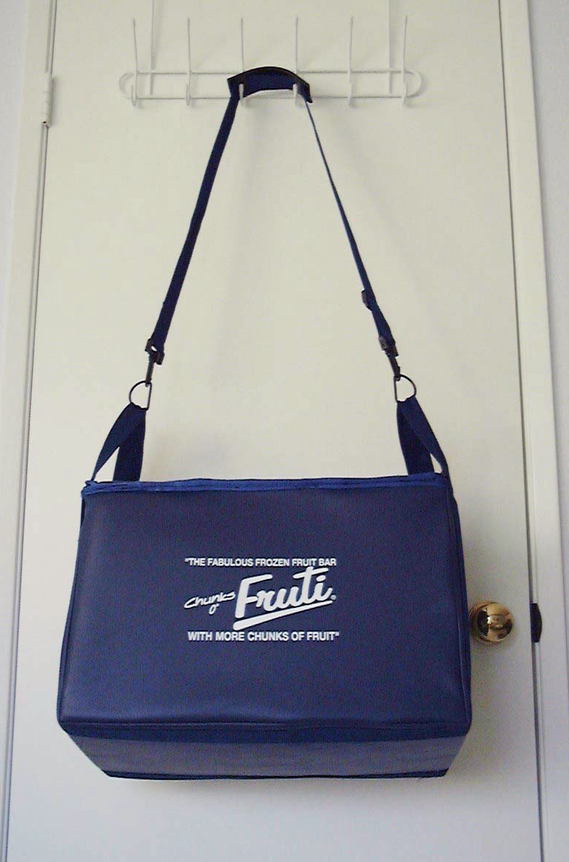

Fruti Vending Bag
With neck strap
(18”x12”x12” with 6.5” Easy Access Door)

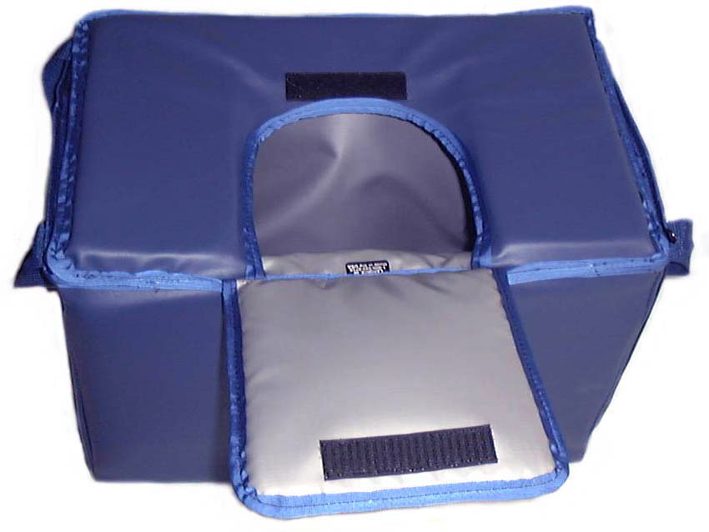

Fruti Vending Bag
With easy-access
Velcro closure
Access door open

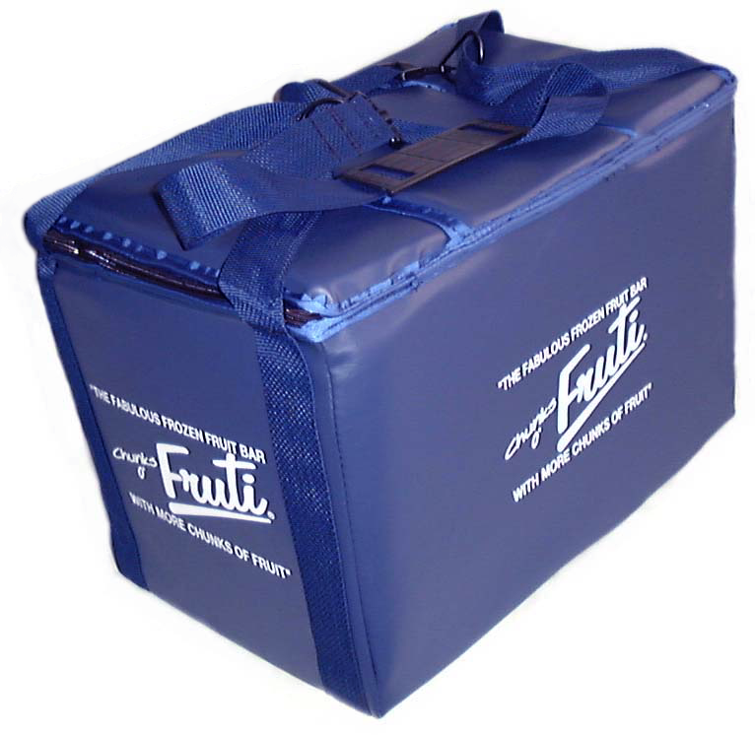

Fruti Vending Bag
Front and Side View with top zipper closed

Please call for current cost and availability.

