CHUNKS 0' FRUTI is 100% Natural ... made with chunks of real fruit, low in calories, no cholesterol, no sodium, no fat, consistent high quality, and versatile uses. Pre-mixed for Cost control and it Tastes Great!

Flavors:
Pina Colada | Banana | Peach
Strawberry | Mango | Caribbean Mix
Margarita | Raspberry | Ice Cream Mix
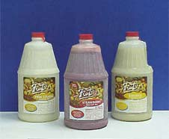
Packed:
CHUNKS 0' FRUTI is packed in a convenient 6-1/2 gallon case and have a 2+1 mix ratio.
These 100% All Natural Mixes are designed for making a high quality frozen drink.
They not only can be used in a blender, but in almost any frozen cocktail machine.
Shelf Life: 18 Months when Frozen | 2 Weeks while refrigerated
CHUNKS 0' FRUTI is easy to handle, it comes in safety sealed plastic bottles, just thaw and pour There is no waste, providing for a consistent ingredient cost.

